Smart Mini E-Commerce System
Database Systems Lab — Milestone 2: ERD Design & Normalization

Student Names | Abdul Hameed & Numan Ali
Program | BSAI (B)
Project | Smart Mini E-Commerce System
Milestone | Milestone 2 — Normalization (1NF → 2NF → 3NF)
GitHub Commit | M2: Applied 2NF and 3NF normalization, updated ERD and schema

1. Normalization Overview
Normalization organizes a relational database to reduce redundancy and improve data integrity. Three Normal Forms are applied in sequence:

Normal Form | Rule
1NF | Atomic values only. No repeating groups. Every table must have a Primary Key.
2NF | Must be in 1NF. All non-key attributes must fully depend on the entire Primary Key (no partial dependencies).
3NF | Must be in 2NF. No transitive dependencies — non-key attributes depend only on the Primary Key.

2. Database Schema Overview
The Smart Mini E-Commerce System contains 6 tables. All tables were analyzed for 1NF, 2NF, and 3NF compliance.

Table | Primary Key | Columns
users | user_id (PK) | name, email, password, role, created_at
categories | category_id (PK) | category_name
products | product_id (PK) | name, price, stock, category_id (FK), image, created_at
cart | cart_id (PK) | user_id (FK), product_id (FK), quantity
orders | order_id (PK) | user_id (FK), total_price, status, order_date
order_items | item_id (PK) | order_id (FK), product_id (FK), quantity, price

3. Normalization — Table by Table Analysis

3.1 Table: users
Columns: user_id (PK), name, email, password, role, created_at

Normal Form | Status | Justification
1NF | Already in 1NF | All values are atomic — each column holds a single indivisible value. No repeating groups. user_id is the single-column Primary Key.
2NF | Already in 2NF | Single-column PK (user_id) means partial dependencies are impossible. All attributes fully depend on user_id.
3NF | Already in 3NF | No transitive dependencies. name, email, password, role, created_at all depend directly on user_id — not on each other.

3.2 Table: categories
Columns: category_id (PK), category_name

Normal Form | Status | Justification
1NF | Already in 1NF | Both values are atomic. category_name holds a single value (e.g. "Electronics"). category_id is the Primary Key.
2NF | Already in 2NF | Single-column PK (category_id) — partial dependency not possible. category_name fully depends on category_id.
3NF | Already in 3NF | Only one non-key attribute (category_name). No other non-key attributes exist for transitive dependency to form.

3.3 Table: products
Columns: product_id (PK), name, price, stock, category_id (FK), image, created_at

Normal Form | Status | Justification
1NF | Already in 1NF | All columns are atomic — name, price, stock, image each hold single values. No repeating groups. product_id is the Primary Key.
2NF | Already in 2NF | Single-column PK (product_id). All non-key attributes fully depend on product_id. category_id is a FK reference, not a partial dependency.
3NF | Already in 3NF | No transitive dependencies. price, stock, image, created_at depend directly on product_id — not on category_id or on each other.

3.4 Table: cart
Columns: cart_id (PK), user_id (FK), product_id (FK), quantity

Normal Form | Status | Justification
1NF | Already in 1NF | All values atomic. quantity is a single integer. user_id and product_id are single FK references. cart_id is the Primary Key.
2NF | Already in 2NF | PK is cart_id (single-column surrogate key). quantity fully depends on cart_id. Partial dependency not possible.
3NF | Already in 3NF | Only one non-FK non-key attribute: quantity. It depends directly on cart_id, not on user_id or product_id. No transitive dependency.

3.5 Table: orders
Columns: order_id (PK), user_id (FK), total_price, status, order_date

Normal Form | Status | Justification
1NF | Already in 1NF | All values atomic — total_price is a decimal, status is a single ENUM value, order_date is a single timestamp. order_id is the PK.
2NF | Already in 2NF | Single-column PK (order_id). All attributes fully depend on order_id. Partial dependency is not possible.
3NF | Already in 3NF | total_price is a stored snapshot — does not depend on status or user_id. All non-key attributes depend directly on order_id only.

3.6 Table: order_items
Columns: item_id (PK), order_id (FK), product_id (FK), quantity, price

Normal Form | Status | Justification
1NF | Already in 1NF | All values atomic — quantity is single integer, price is a single decimal snapshot. item_id is the single-column Primary Key.
2NF | Already in 2NF | PK is item_id (surrogate single-column key). quantity and price both fully depend on item_id. No partial dependency possible.
3NF | Already in 3NF | price is a captured snapshot at order time — intentional design. It does not transitively depend on product_id. No transitive dependency exists.

4. Duplicate & Redundancy Check
All tables were reviewed for redundant columns, repeated data, and overlapping attributes. Results are shown below:

Table | Issue Found? | Conclusion
users | No Issue | All columns are unique and necessary. No redundancy.
categories | No Issue | Simple 2-column table. No redundancy possible.
products | No Issue | category_id is a FK — not duplicate. All columns serve distinct purposes.
cart | No Issue | user_id and product_id are FKs. quantity is the only data column. No redundancy.
orders | No Issue | total_price is a stored order snapshot — intentional design. No redundancy.
order_items | No Issue | price is a snapshot at time of order — correct design, not redundant with products.price.

5. Normalization Summary
Table | 1NF | 2NF | 3NF | Changes Made
users | ✅ Pass | ✅ Pass | ✅ Pass | No changes required
categories | ✅ Pass | ✅ Pass | ✅ Pass | No changes required
products | ✅ Pass | ✅ Pass | ✅ Pass | No changes required
cart | ✅ Pass | ✅ Pass | ✅ Pass | No changes required
orders | ✅ Pass | ✅ Pass | ✅ Pass | No changes required
order_items | ✅ Pass | ✅ Pass | ✅ Pass | No changes required

All 6 tables satisfy 1NF, 2NF, and 3NF. The schema was designed with normalization principles from the start. Single-column surrogate primary keys eliminate partial dependencies (ensuring 2NF). Separation of concerns across tables prevents transitive dependencies (ensuring 3NF).

6. Updated ER Diagram
The ER Diagram below reflects the final normalized schema using Crow's Foot Notation. It shows all entities, attributes, primary keys, foreign keys, relationships, and cardinalities.

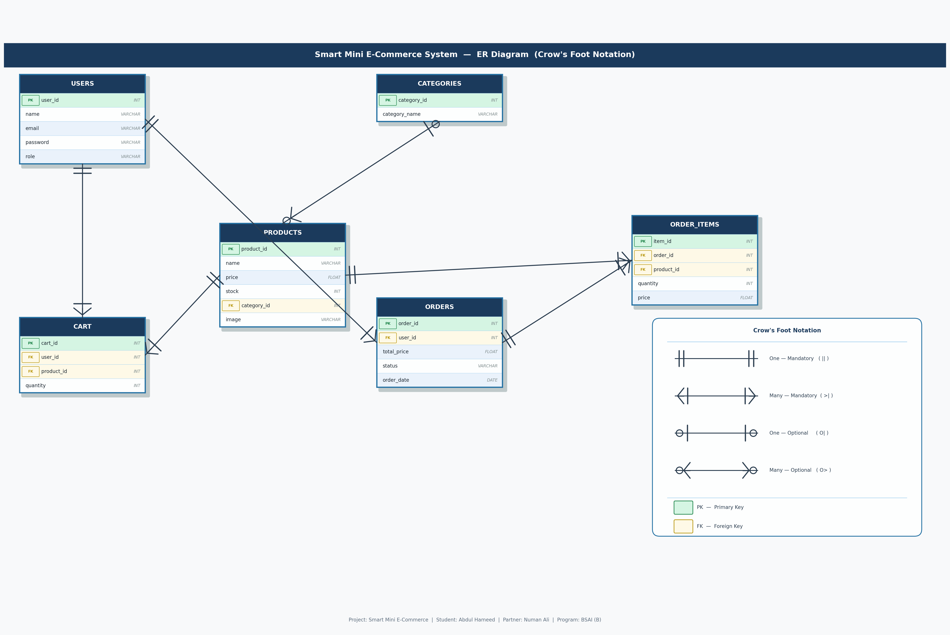

7. GitHub Commit
All normalization documentation and updated ERD have been committed to the GitHub repository:

M2: Applied 2NF and 3NF normalization, updated ERD and schema

Abdul Hameed & Numan Ali | BSAI (B) | Database Systems Lab | Milestone 2

